New web site texts

**Background**

Dr. Tyurin has gotten his M.D. in Internal Medicine, 1986, (in addition to the M.Sci. in Biology (1985) and the B. Sci. in Biological Engineering (1984)) from Saratov State University and his Ph. D. in Molecular Biology, Microbiology and Molecular Pharmacology, 1990, from the USSR Research Institute for Antibiotics. Life has changed substantially with the decomposition of the Former Soviet Union, and Dr. Tyurin had to move to the US to get at least the normal salary and normal daily food. He still continued to work for somebody till 2007, despite he became independent from the Immigration Services in 1999. In 2007 Dr. Tyirin became totally free and started working for himself only. He started his company Syngas Biofuels Energy, Inc., where he created his major work and the publications, devoted to the seven indepenent carbon negative technologies to manufacture important commodity chemicals and fuels. The Corporate web site, which Dr. Tyurin has developed <http://syngasbiofueslenergy.com> along with the Corporate Emails were deleted, since the competing lawyer from one Houston law firm, who in the Civil Court of Law openly stated, she has accessed Dr. Tyurin’s Corporate computer and she has access to all his pawsswords, so she has made said Corporate wb site dead after she changed the credit card number and its expiration date. The same work continued at Microbial Biocatalyst International, Inc. and Inorgcarbdiesel, Inc,, the companies, created to commercialize the disruptive technologies of atmospheric CO2 coversion to the improtant commodity chemicals and fuels. Now Dr. MV Tyurin own Biocatalyst International, inc., and this Corporate site replaces already established Corporate web site, which dies, by this Corporate web site. Dr, Tyurin has never had any plans for his personal security and the security of his businesses. But the thurth is, that major businesses invest very mcuh in that security direction. For instance, Mr. Michael Dell in 2016 spent about $3 million on the personal and his family security. Now this amount, probably, will approach to $10 million or so.

**Commodity chemicals and fuels from the air CO2**

Replacement of gasoline from petroleum to Isobutanol or n-Butanol has been done prior to Dr. Tyurin by many others. Nevethe less, nobody tried to establish the commercial manufacture of the gasoline replacenets or the diesel fuels replacements, specifically, made soley from the air CO2. Dr. Tyurin’s misson is the organizing od the the bulk commercial manufacture of the Gasoline replacement Isobutanol from air CO2 and N2 for the firsrt time in history. Diesel fuel from petroleum can be substituted by diacetyl alcohol with the same energy and hit rate production as diesel fuel. Diacetyl alcohol is the product of inexpensive fusion of two acetone molecules over the alkaline catalyst. Aceton from air CO2 manufacturing technology is also designed by Dr. Tyurin. Here are the years of noted technologies development: (2012) Acetone, (2012-2013) Mevalonate, 2,3-Butanediol, Methanol, Formate, Ethanol, n-Butanol, (2014, 2019) Isobutanol. Isobutanol, purely technically, has the same energy of combustion of the Gasoline, but it is viscous, if used 100%. Said viscosity limits Isobutanol use at the temperatures below the water freezing point. Therefore, Dr. Tyurin’s Commercial Isobutanol as the Gasoline replacement is used mixed with the gasoline, at the ration 80% of the isobutanol and 20% of the Gasoline to prevent the car fuel lines blockage with said very viscous isobutanol. The product of said Ispbutanol combustion is the same CO2 emitted to the air. So, the problem is solved by the total replacement of the Gasoline manufacture from petroleum by the Commercial Isobutanol manufacture from air CO2. Under that circumstance, the air of the Earth will become as prior to the petroleum and its distillation products combustion era, happening today, with the Gasoline replacement Commercial manufacture using Dr. Tyurin’s prprietary technology just within the next about 70 years. For said time, Dr. Tyurin is developing foods, made solely from air CO2 and comprising real taste of meat fibers of real meat for the Humankind, which will be starving very shortly from now from the evapoartion of the fresh water to the outer Space, surrounding our planet.

**Environmental concern of Dr. Tyurin**.

Dr, Tyurin has become enviornmentally concrened in the year of 2000. Creation of petroleum by the Nature took over several million years. Followed by coal replacement in steam engines by petroleum in early 1900s then was continued by wide spreading of diesel engines with significant energy production yields. Growing autoindustry was based on the gasoline and diesel fuel use. Wide net of the interstate roads, sorrunding the US, has stinulated the gGassoline and the diesel fuel use for the tyransportation purpose. Gasoline and diesel fuel are obtained from petroleum by the refinery-based petroleum distillation to varous fractions, C7 - C9 gasoline petroleum fraction, C10-C14 diesel fuels fraction. Intensive petroleum use in many countries has lead to almost complete exhaustion of the natural petroleum reserves in less then 200 years. In 2010 NASA has bomarded the Earth satellite Moon to examine by the modern chemical methods the debris of the explosions. The result was evironmentally disturbing: NASA has found plenty of ice on the dark Moon surface. NASA was guessing where said ice has come from. The ground for the Environmental Concern of Dr. Tyurin: Dr. Tyurin was working with bacterial lyophilization for over 30 years and he knows, that in vacuum, when the cultures are dried, the water gets collected on the cold springs, where cold is produced. The source of such ice is the bacterial cultures, placed for freeze-drying. Now, Earth is the planet in the Space vacuum. If ice was found on the Moon located in 220000 miles distance from Earth, the ice souce was the Earth, the closest object to the Moon. How water evaporates from Earth? This is a long but very disturbing story with the very unhappy ending. Again, early 1900s were the time of the beginning of the intensive use of petroleum and the products of the petroleum distillations at the refineries.

*In the US there are 80 refineries. To build one refinery it costs over $500 million, plus the refineries maintenance costs over $250 million every five years.*

in 2010 NASA has come to the disturbing conclusion after finisning chemical examination of the Moon explosion products. The NASA conclusion was that the Earth has passed the **point of no return** in tne air CO2 accumulation. In 2010 the air CO2 content was determined as 400 ppm, now it is over 450 ppm. Where does the air CO2 come from? The air CO2 is the product of petroleum and gasoline/diesel fuel combustion and the product of breathing of all the living beans on our planet Earth. The petroleum reserves now have become almost completely exhausted and the Earth population doubles every 35 years due to wide use of antibiotics and vaccines dramatically reducing humankind mortality. There is the projection, that the Earth population in 2050 will be 14 billion people (Tyurin M. (2013) (Invited) Reversal of global warming using $3 trillion market force: chemicals and fuels produced directly and selectively in continuous fermentations of gas blends comprising CO and CO2. In: Environmental Aspects of Global warming. Nova Science Publications Press. – New Developments in Global Warming Research. Eds: Carter B. Keyes and Olivia C. Lucero. [https://www.novapublishers.com/catalog/product_info.php?products_id=46570](https://www.novapublishers.com/catalog/product_info.php?products_id=46570")).

What is the effect of the air CO2? CO2 is one of the heaviest gases in the air blend along with theminotr portion of the inert gases. Air is a gas blend, with no external ventillation segregating based of the gases gravity. Air average gravity was determined as 1.2 g/m3. The air CO2 has its density of 1,997 g/m3. Under no wind conditions, the air CO2 spreads on the ground surface. Air CO2 selectively absorbs solar infra red energy prodcing heat thus heating ground, often over 100o C in the States like TEXAS. This cretes axtra fresh water evaporation from the soil. Groud is the main source of the fresh water, then forming rivers, lakes, ect. Such extra fresh water vapors crom the heated by Sun groud are distributed in the air. Air is attached to the Erath surface by the air weight under the constant gravity force. The gavity force has been stable in Earth for the last billions years. Extra fresh water vapors are distriuted all over the air. The end of the Earth air mass is the Space vaccum. So, Sapce vacuum sucks fresh water vapors from the Earth air and said vapors become travelling in the Space away from the Earth. Some of them were tralled on the very cold dark Moon surface as found by NASA in 2010. More fresh water vapors are produced now because of the Earth overpopulation and the intensive use of petroleum and the products of its distillation for the transportation purpose. Therefore, more fresh water vapors are leavind the Earth atmosphere and travel in Sapce in the unknown direction. Dr. Tyurin has referrred to the NASA experience in 2010, and the NASA was guessing where said water found on the Moon surface was coming from? Eventually, said water was coming from Earth, and the Moon worked as the cold trap in the Space vaccum, just like the coils of the coolant during bacterfial lyophilization mentioned herein.

The loss of the fresh water per above is explained additionally in the following picture:

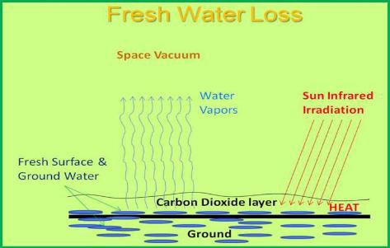

Let’s examine the water reserves of the Earth.

There is the picture obtained from the public source http://ga.water.usds.gov/edu/earthwherewater.html.

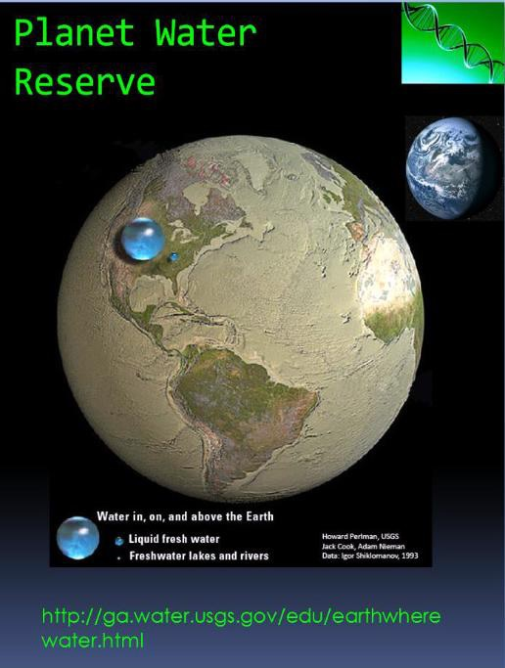

Environmental Concern of Dr. Tyurin

The following schematic diagram explains all the environmental concerns of Dr. Tyurin, now availabe as the public information (Tyurin M. (2013) (Invited) Reversal of global warming using $3 trillion market force: chemicals and fuels produced directly and selectively in continuous fermentations of gas blends comprising CO and CO2. In: Environmental Aspects of Global warming. Nova Science Publications Press. – New Developments in Global Warming Research. Eds: Carter B. Keyes and Olivia C. Lucero. [https://www.novapublishers.com/catalog/product_info.php?products_id=46570](https://www.novapublishers.com/catalog/product_info.php?products_id=46570")).

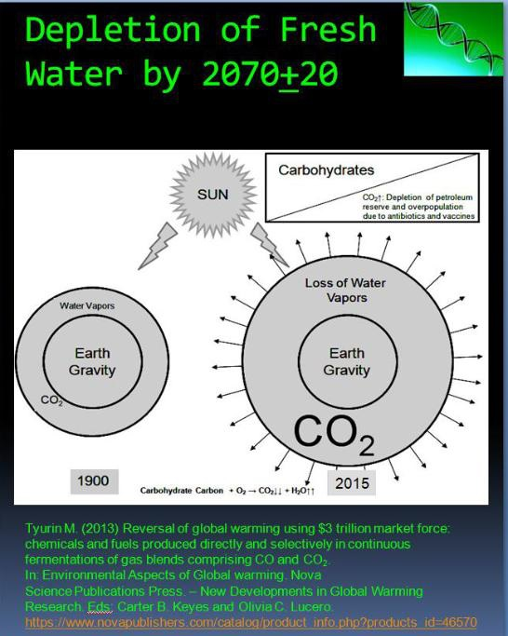

The fresh water depletion time is given very approximately as Dr. Tyurin is not the majician for said predkictions. It can be even shorter, like 10-20 years from now. What are the consequences of said fresh water depletion? No fresh water means no crops and no livestock production. That means coming at said time global shortage of fresh water and of any sort of food. Literally, at said time **fresh water will become the currency**. People will kill for the glass of resh water and gamburger. There would not be any washing of our bodies and clothes. What would be the social and economic changes? It is hard to guess now, but said situation will be very unpleasant for everyone. What to do? There are growing investments in the extra Space travel industry to discover planets for the relocation of the overcrowded Earth. Many talented and educated well capitalists now invest in the technologies to make the Spacecrafts, capable of leaving Earth and travel to the other planets. Eventually, the speed of said process is very low, and by the time of the fresh water depletion it is most likely, that there will not be any new planet found to relocate the overcowded Earth population. OK. the solution #1 has been found - to identify new planet for the earth population relocation. Dr. Tyurin also has the 2nd solution: to stop further petroleum and its distillation products combustion and to widely implement said developed by Dr. Tyurin disruptive carbon negative technologies to manufacture current commodity chemicals and fuels from the petroleum and related. Dr. Tyurin has made some preliminary calculations how long will that take to bring the Earth air CO2 content to the pre-petroleum itense use era, **the begining of 1900s**. Based on Dr. Tyurin calculations, at the global distribution of his carbbon negative technologies the reduction of the air CO2 content to the level of 1900s will take approximately 70 years or longer. Market force is the FREE force. Dr. Tyurin has no any competition on the current existing market of commodity chemicals and fuels, exceeding now $3.2 trillion.

Now, there will be the time of the global starvation on Earth. What to do? Any means to decrease the Earth population are not only immoral, but also useless. There is the event\ual need to create carbon negative technologies for the food manufacture from the air CO2. This is a very complicated proposed program with many possible technical solutions. Dr. Tyurin has identified for the first time in the history the problem of the coming to Earth global food shortage due to the extra evaporation of the fresh water to the outer Space. Threfore, now it is for Dr. Tyuirn to develop the solution how to make foods from the air CO2 and ensure the easing of the coming to Earth global ecological catastrophe identified in the paragraphs before.